**GHANA COMMUNICATION TECHNOLOGY UNIVERSITY (GCTU)**



**FACULTY OF COMPUTING AND INFORMATION SYSTEMS**

**DEPARTMENT OF INFORMATION SYSTEMS**

**END OF SEMESTER ASSIGNMENT**

**CICS 313: INTERNET TECHNOLOGY & WEB DESIGN**

|  |
| --- |
| **STUDENT INFORMATION** |
| INDEX NUMBER: **4211210486**  FULL NAME: **Patrick Asankomah Danso**  PROGRAMME: **BSC INFORMATION TECHNOLOGY**  LEVEL: **300**  SESSION: **MORNING (GROUP B)**  LECTURER: **DR. WILLIAM BROWN** |

TITLE: RESTAURANT WEBSITE DESIGN

**TABLE OF CONTENTS INTRODUCTION ...................................................................................4 1.1INTRODUCTION ...................................................................................... 4**   **1.2 OBJECTIVE OF STUDY ......................................................................... 4**

**1.3. SCOPE OF STUDY………..………………………………… 4**

**1.4 LIMITATIONS ………………………………………………... 4**

**2.0 LITERATURE REVIEW ................................…………………….5**

**2.1 SYSTEM ANALYSIS AND DESIGN …....…………………………5**.

**2.2 REQUIREMENT ANALYSIS…………………………………….…. 5**

**2.3 SYSTEM DESIGN ………………………………………...….……….6**

**2.4 BREIF DESCRIPTION ………………………………………………8**

**2.5 SYSTEM DOCUMENTATION………………………………………8**

**2.6 HOME PAGE …………………………………………………………. 8**

**2.7 LOCAL MENU PAGE……………………………………. 9**

**3.1 INTERCONTINENTAL MENU PAGE …………………………………………….…9**

**3.2 DESSERTS PAGE …………………………………………………….…10**

**3.3 CONTACT INFO PAGE …………………………………………………...…….11**

**3.4 SUMMARY …………………………………………………...…….11**

**3.6 SUGGESTED FOR FUTHER UPDATE………………….………12**

**Introduction:**

The restaurant website is an essential tool for any restaurant's online presence. It serves as a digital storefront and can help attract new customers and retain existing ones. A well-designed and informative restaurant website should provide customers with all the information they need to make an informed decision about visiting or ordering from the restaurant. In this documentation, we will discuss the essential components of a restaurant website and provide tips for optimizing them.

Homepage:

The homepage is the first page that customers will see when they visit the website. It is visually appealing and provide an overview of your restaurant's offerings. The homepage includes the restaurant's name, logo, and a brief description of your cuisine.

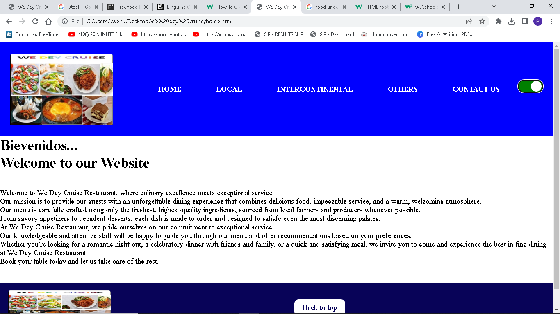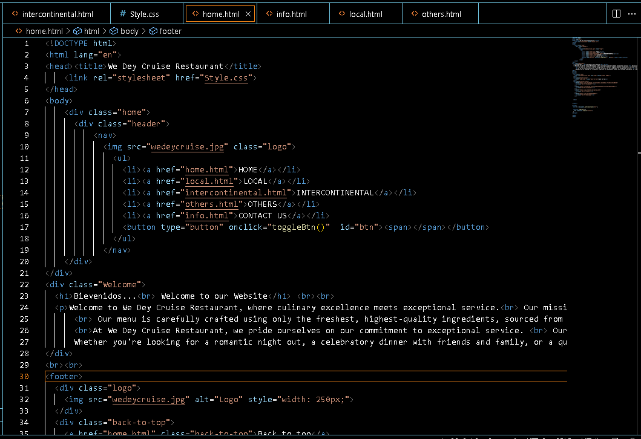

Menu:

The menu is one of the most important components of a restaurant website. It should be easy to navigate, visually appealing, and informative. Each menu item should include a description, price, and a high-quality image. You may also want to include information about any special dietary considerations, such as gluten-free or vegan options.

Local Dish Menu:

The Local Dish Menu contains the available local dishes we have to offer.

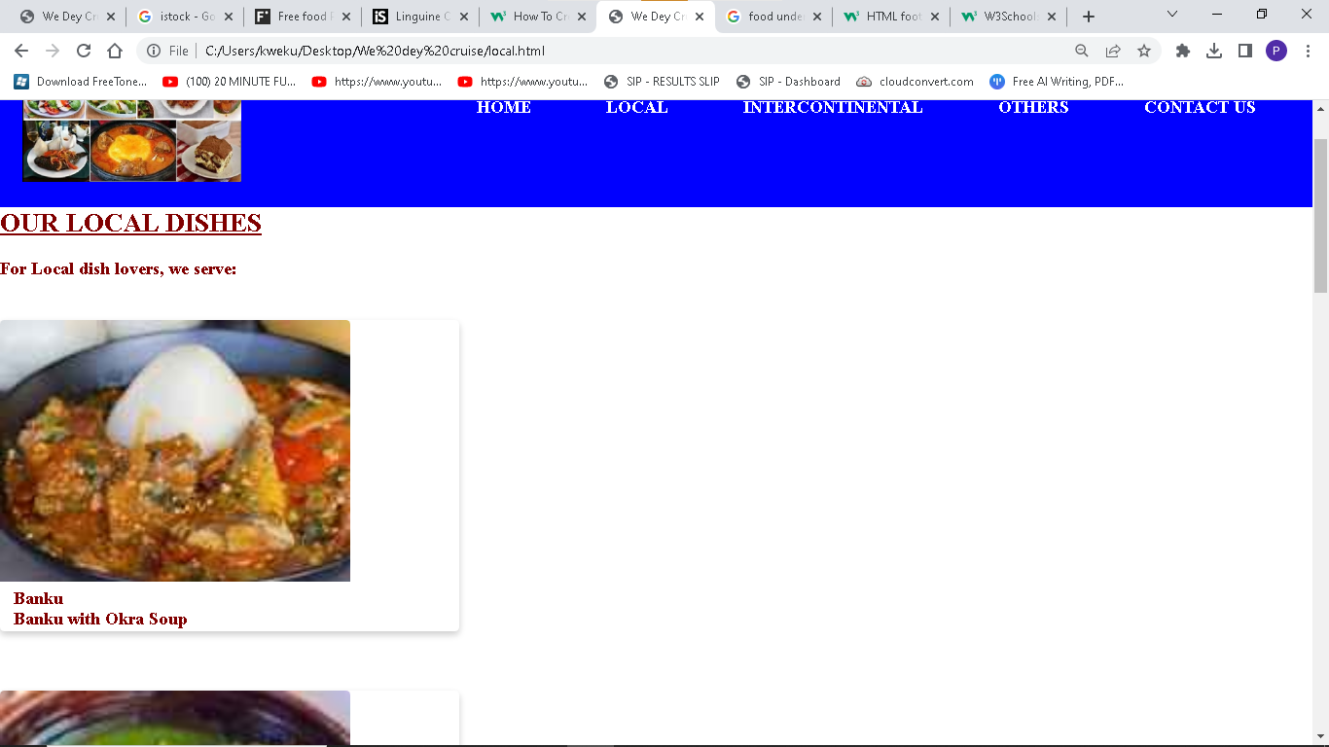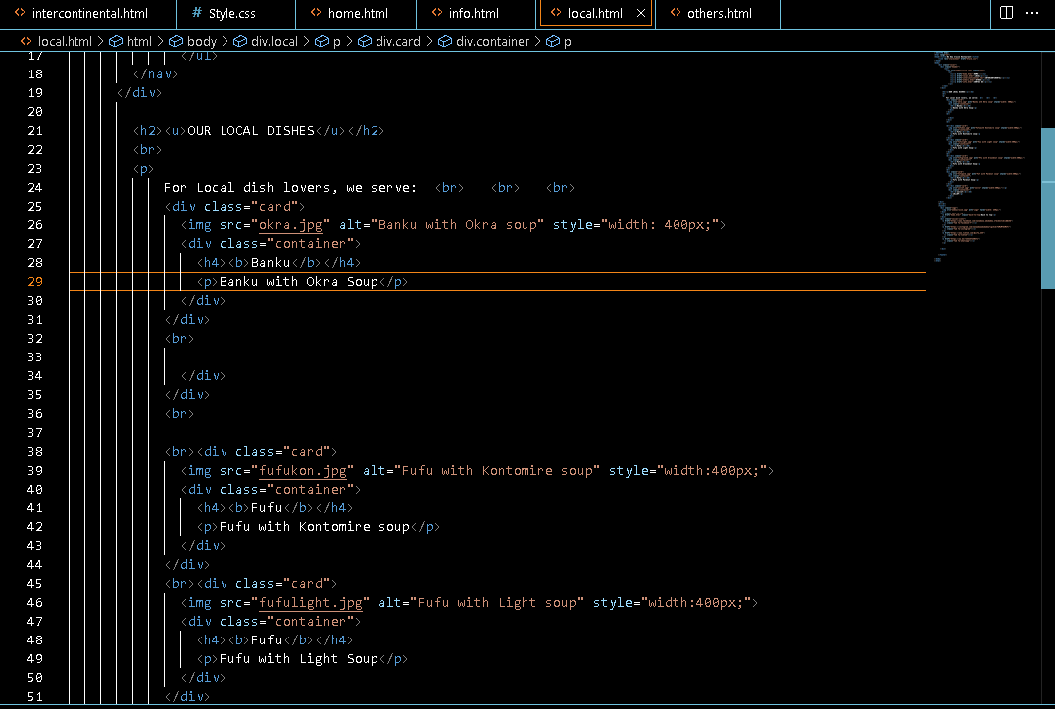

Intercontinental Dish Menu:

The Intercontinental Dish Menu contains the available intercontinental dishes we have to offer.

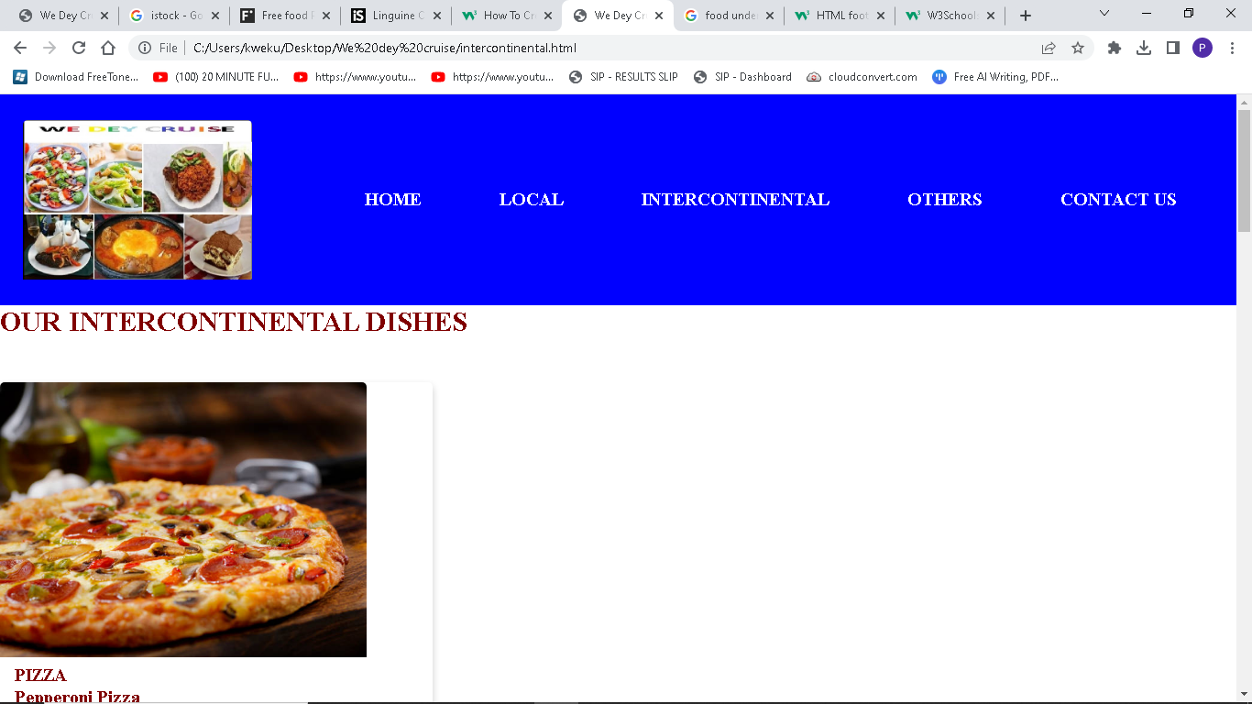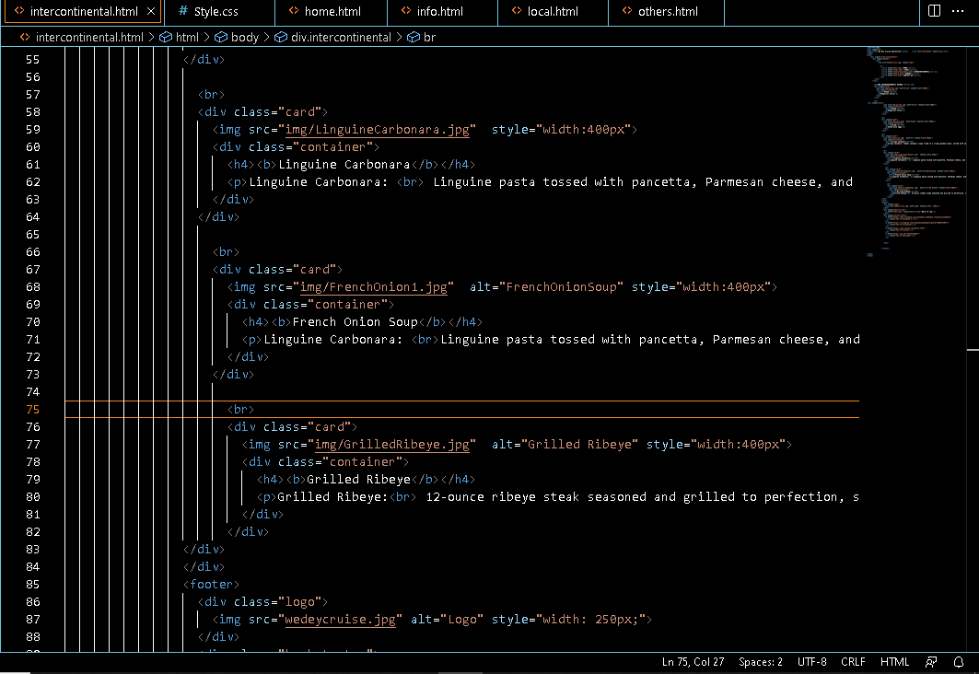

Dessert Menu :

The Dessert Menu contains the available desserts we have to offer.

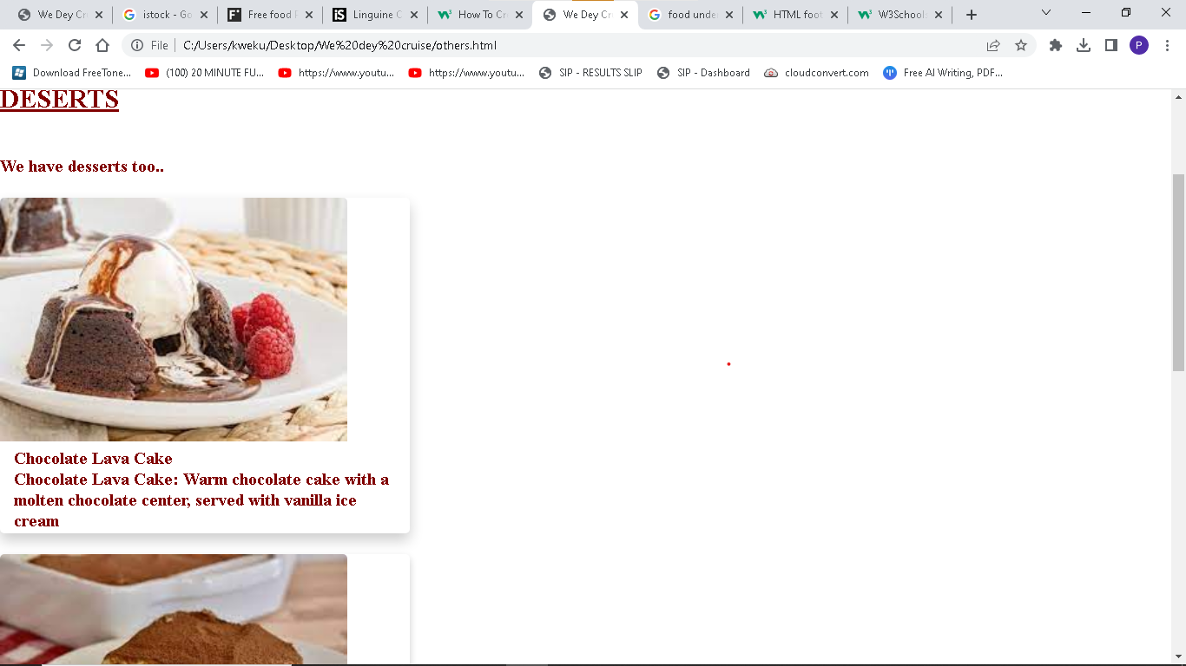

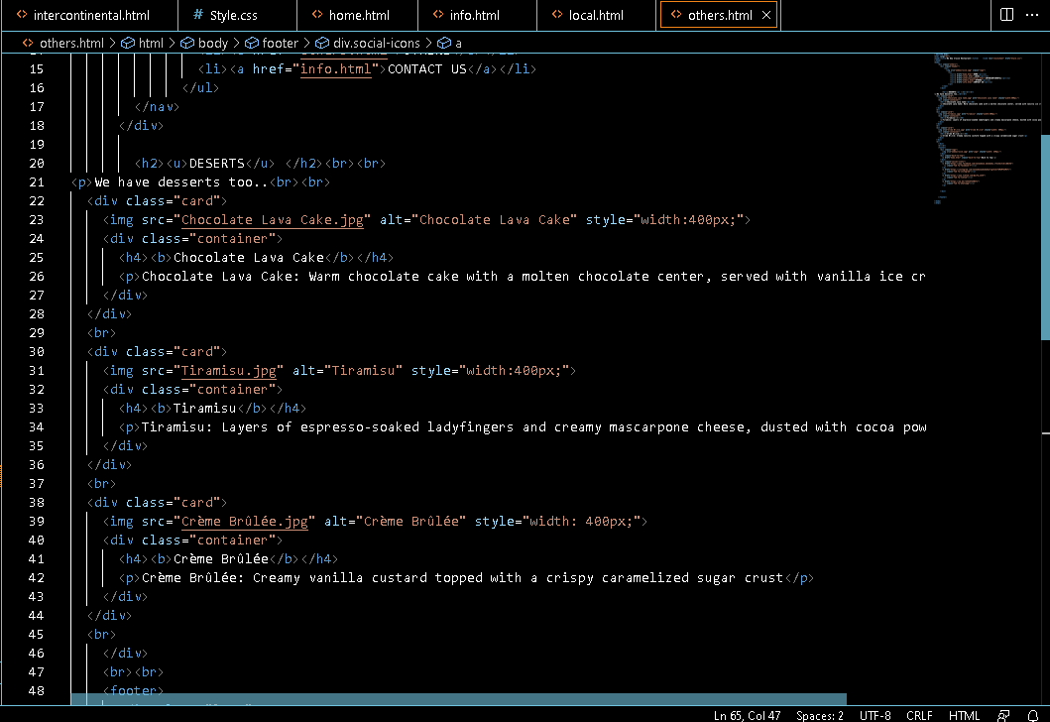

**Location and Contact Information:**

Make sure to include your restaurant's location and contact information on your website. This should include your restaurant's address, phone number, email address, and hours of operation. You may also want to include a map of your location to make it easier for customers to find you.

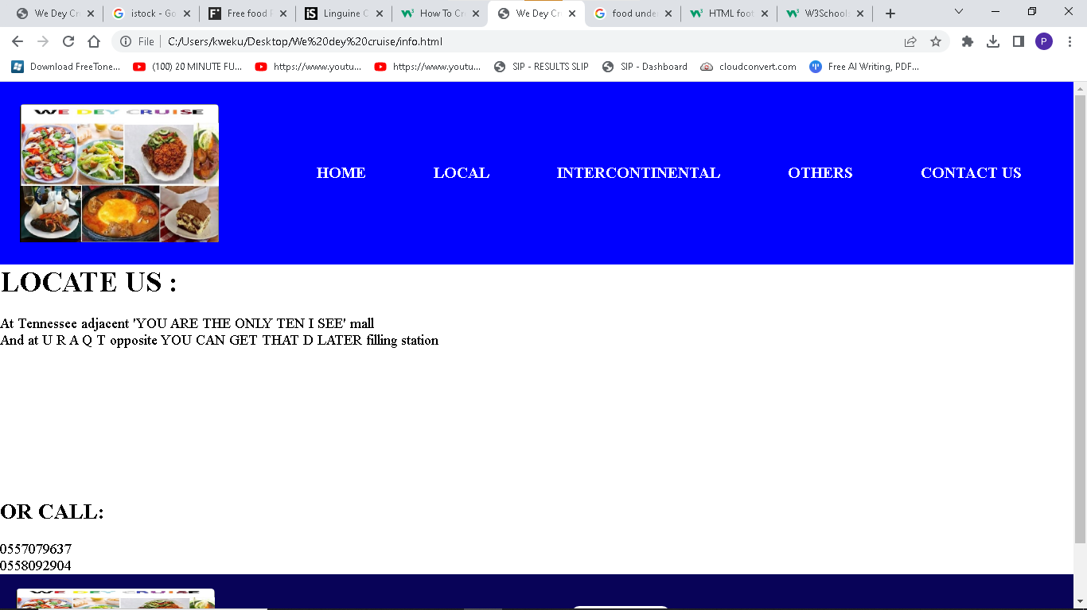

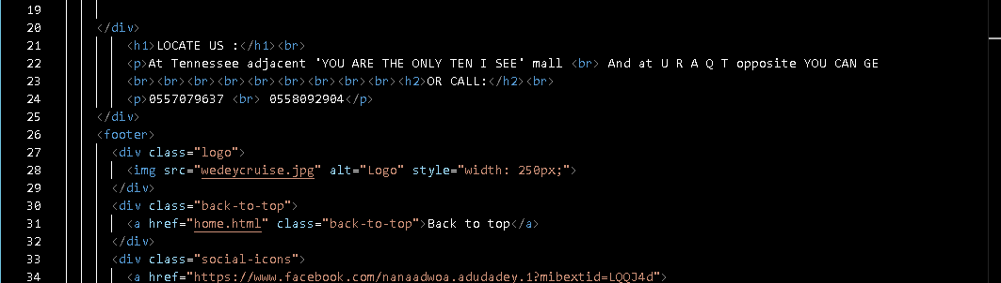

**CSS CODE**

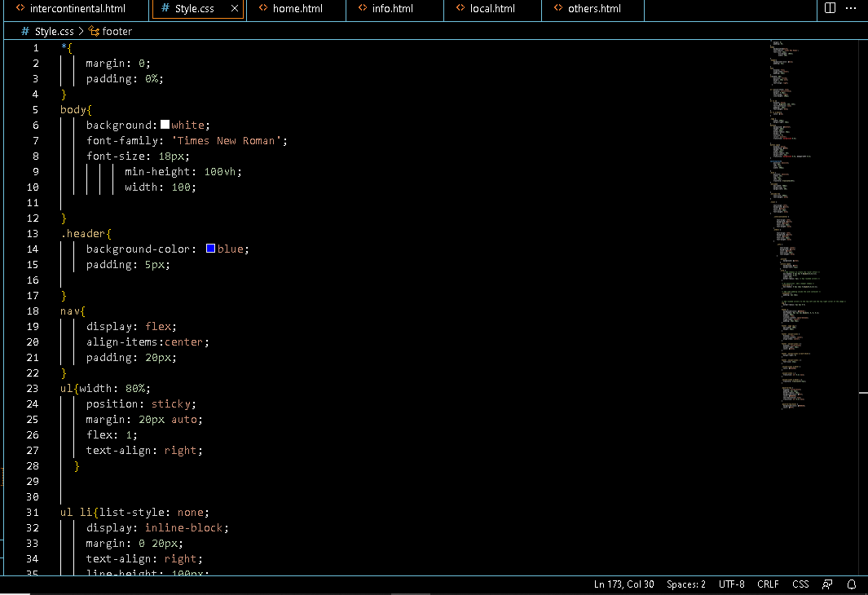

About Us:

Include an "About Us" section on your website to provide customers with more information about your restaurant. This section should include your restaurant's history, mission statement, and any awards or accolades you have received.

Special Events and Promotions:

If your restaurant offers special events or promotions, such as live music or happy hour specials, make sure to include this information on your website. This can help attract new customers and keep existing customers engaged.

Mobile-Friendly Design:

Make sure that your website is mobile-friendly. Many customers will be viewing your website on their mobile devices, and a mobile-friendly design will ensure that your website is easy to navigate and use on smaller screens.

Conclusion:

A well-designed and informative restaurant website can help attract new customers and retain existing ones. By including essential components such as a homepage, menu, reservation system, location and contact information, about us section, and information about special events and promotions, you can create a website that is both visually appealing and informative. Make sure to optimize your website for mobile devices, and you'll be well on your way to building a strong online presence for your restaurant.